BlackWall – Protect an AI from going rogue via an AI
Parsa Besharat
parsa@hounaar.com
Abstract
The increasing integration of social media and conversational AI into daily life has intensified concerns around the spread of harmful, illegal, and psychologically sensitive content, including suicidal ideation, self-harm, depression, and other forms of negative influence. Recent cases of emotional attachment to chatbots and instances where AI systems have unintentionally misled users on mental health issues highlight the urgency of reliable safety mechanisms. This paper presents Blackwall, a domain-aware and interpretable framework designed to identify, assess, and rank high-risk content across online platforms. By operating across heterogeneous data sources and providing transparent risk explanations, Blackwall supports early intervention, responsible moderation, and safer human–AI interaction. The framework aims to contribute toward ethically grounded content safety systems that can mitigate psychological harm while preserving transparency and trust.
Department of Math and Computer Science, Technische Universität Bergakademie Freiberg, Freiberg, Germany
*Corresponding author: Parsa@hounaar.com

Introduction
The Blackwall project is dedicated to engineering a reliable and interpretable artificial intelligence framework designed to identify suicidal ideation alongside a broad spectrum of harmful, illegal, and psychologically sensitive content. This scope encompasses not only direct threats of self-harm but also the nuanced detection of depression, misleading information, and negative behavioral influences. Unlike standard content moderation tools that monitor social media feeds, Blackwall is architected as an internal safety mechanism, trained on curated datasets to actively prevent intelligent systems from generating or validating dangerous outputs. As generative AI models become increasingly autonomous, the capacity to internally audit and suppress harmful responses has become a fundamental requirement for safe deployment.
To achieve this, Blackwall integrates domain-aware training with rigorous generalization analysis, ensuring stability across heterogeneous data environments. This approach specifically addresses the opacity often inherent in deep learning models by prioritizing transparency through explainable risk assessment protocols. By delivering interpretable decisions and maintaining resilience under distribution shifts, Blackwall functions as a critical defense layer against unsafe or rogue AI behaviors. Ultimately, this project seeks to bridge the gap between technical capability and ethical safety, establishing a standard for ensuring that future human–AI interactions remain trustworthy and secure.

Background and Related Work
Sawhney et al. (2020) propose STATENet, a neural model that combines tweet-level text with user-level emotional history to detect suicidal intent in English tweets [1]. While this context-aware design improves prediction over isolated posts, the binary formulation and heavy reliance on affective signals limit fine-grained risk assessment and may conflate emotion with intent.
Jakub Pokrywka, Jeremi I. Kaczmarek, and Edward J. Gorzelańczyk (team kubapok) demonstrated in the IEEE BigData 2024 Cup that a fine-tuned GPT-4o model achieved second place in suicide risk classification, outperforming standard DeBERTa baselines. While DeBERTa models are frequently used for this four-class task (Indicator, Ideation, Behavior, Attempt) [2], the authors highlight that existing implementations often suffer from statistical flaws [2]. Specifically, they note that reliance on non-stratified validation splits and inadequate handling of class imbalance often led to unstable metrics and poor detection of rare, high-severity cases.
Yang et al. introduce a hybrid approach combining RoBERTa embeddings with TF-IDF features reduced via PCA for multi-class suicide risk prediction on Reddit data [3]. Although effective, the method remains computationally expensive, difficult to interpret, and constrained by transformer sequence length limits.
Markov et al. present a real-world content moderation framework that integrates structured taxonomies, active learning, synthetic data, and Domain Adversarial Training to improve robustness for harmful content detection [4]. Despite strong real-world performance, the system is sensitive to noisy synthetic data and adversarial text perturbations

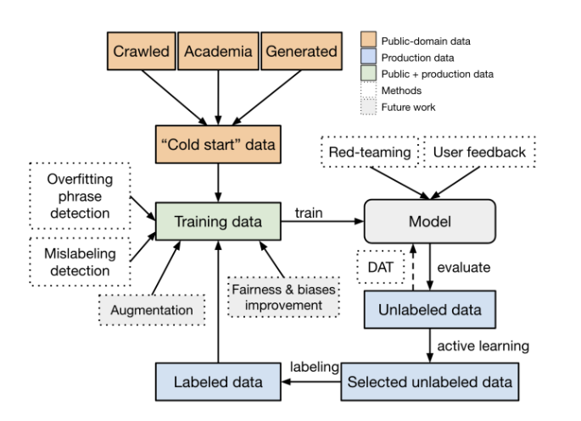
Figure 1 - Overview of the model training framework. [2]

InstructGPT and Human Alignment.
Ouyang and Wu (2022) introduce InstructGPT, which aligns language models with human intent using reinforcement learning from human feedback. [5] While alignment improves safety and usefulness, the authors acknowledge that harmful outputs can still occur, motivating the need for complementary safety mechanisms.
Methodology – Risk Thermometer
BlackWall addresses this by enforcing stratified K-fold cross-validation, ensuring balanced evaluation across all risk categories and preventing validation instability. In the training process, we use Domain Adversarial Training (DAT) for the Neural Networks and Machine Learning algorithms, ensuring the model is PAC Learnable and consistent. We used the Suicidal Tweets Dataset and also Reddit SuicideWatch Severity Dataset for this purpose. Datasets and all source codes are available on GitHub repository: https://github.com/parsabe/BlackWall.
Defining Sensitive Terms and Danger Levels The initial and most critical phase of our methodology involved establishing a robust Multi-Class Classification framework supported by curated Sensitive Lexicons. We defined discrete "Danger Ranks" (Classes) that the model is trained to predict, effectively creating a structured severity spectrum for the analyzed content. As detailed in Table 1, these ranks range from non-sensitive, general conversation (Rank 0) to critical, real-time threats requiring immediate intervention (Rank 4). To support this hierarchical classification, we generated a comprehensive list of sensitive lexicons, assigning a baseline "danger level" to each term to serve as the foundational logic for our feature engineering process.
Rank | Label (Class) | Description
0 | No Risk | Non-sensitive, general conversation.
1 | Low Risk | General discussion, support, or historical/contextual information.
2 | Moderate Risk | Expressions of negative emotion, hopelessness, or vague ideation.
3 | High Risk | Clear expressions of suicidal intent, detailed plans, or explicit threats of self-harm.
4 | Critical Risk | Real-time, imminent threat requiring immediate intervention.
Figure 3 – Overview of the labels and classes.

Foundation and Feature Strategy To establish a solid foundation for our system, we started by creating a comprehensive list of sensitive lexicons and assigning a baseline "danger level" to each term. This served as the basis for our feature engineering.
Text Preprocessing and Optimal Encoding Strategy Effective encoding was achieved through a multi-stage strategy starting with standard tokenization and noise removal. For representation, we selected Deep Contextual Word Embeddings via a Longformer-Based Domain Adversarial Network, chosen for its ability to distinguish between genuine threats and metaphorical usage within full sentence contexts. These embeddings were further augmented with TF-IDF for keyword importance and an Aggregated Danger Score derived from our initial lexical ratings to enhance discriminative power.
Model Architecture and Design We adopted a deep learning approach centered on a Fine-tuned Transformer Model. The architecture utilizes a pre-trained base augmented with a custom classification layer employing fully connected units with RELU, Tanh, and GELU activation functions. A Softmax function is applied dynamically during loss calculation (via CrossEntropyLoss) to convert logits into an interpretable probability distribution mapping directly to the output neurons. We also validated this approach against traditional models like SVM and XGBoost to assess feature utility.
Training, Evaluation, and Output Training addressed data imbalance through stratified sampling, ensuring consistent class distributions. Evaluation prioritized high-stakes metrics, specifically per-class F1-score, Precision, and Recall, ensuring the model remains sensitive to rare, high-risk examples without generating excessive false positives. The final ranking logic relies on a probabilistic determination where the class achieving the highest probability is definitively assigned as the severity rank.

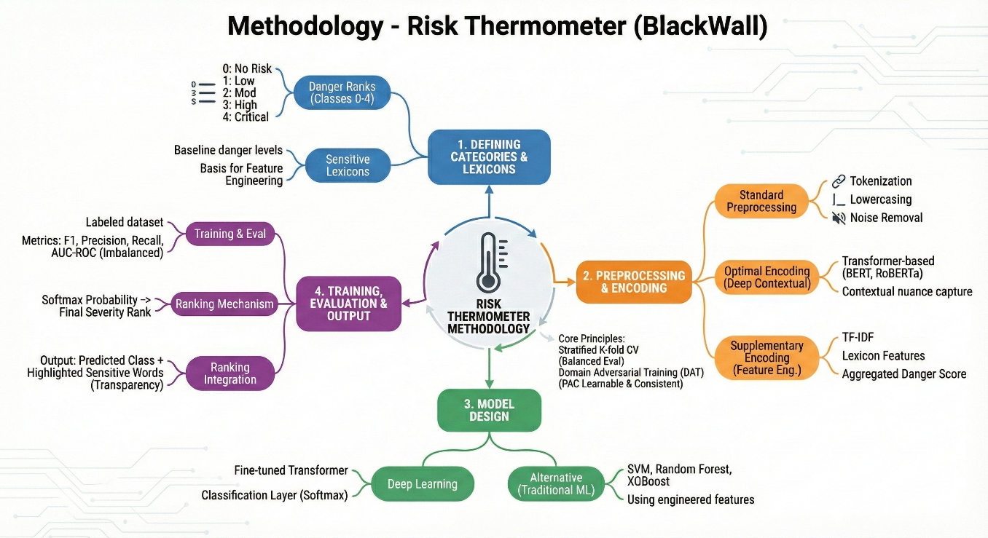

Figure 3 – BlackWall’s operation mind map.

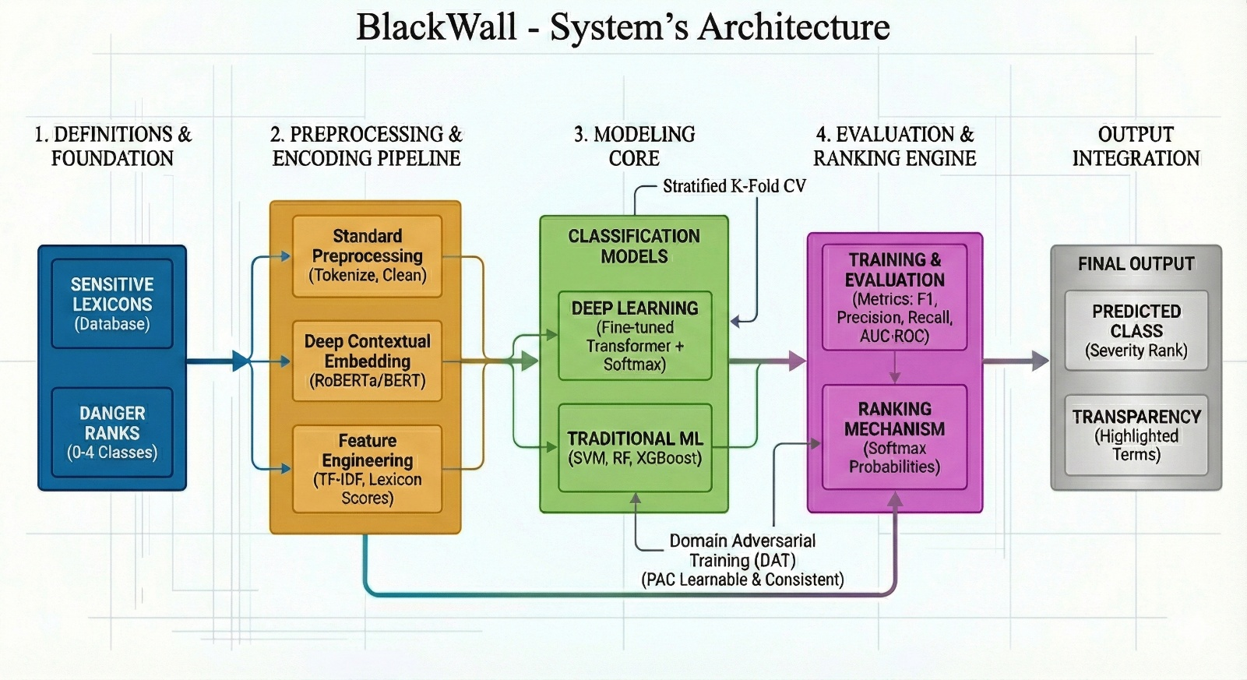
Figure 4 - BlackWall Risk Thermometer Architecture. This pipeline begins by defining risk categories and sensitive lexicons, followed by a hybrid encoding strategy using both deep contextual embeddings and statistical features. It leverages fine-tuned Transformers and traditional ML models to classify content, ultimately generating a final severity rank with transparent, actionable keyword highlights.
Results of Implementation
To assess the inherent separability of the risk categories prior to final model selection, we analyzed the discriminative power of the engineered features using standard performance curves. The results indicate that the features provide strong signal clarity for the spectrum endpoints, with "No Risk" and "Critical Risk" classes achieving high Area Under the Curve (AUC) scores. However, a deeper analysis reveals a structural weakness in the intermediate categories. The steep degradation in precision as recall increases for the "General Risk" and "High Risk" classes indicates significant semantic overlap. This suggests that the decision boundaries between these distinct levels of severity are not linearly separable and require more than surface-level lexical features to resolve effectively.
Following this diagnostic assessment, we established a performance benchmark using Support Vector Machines (SVM), XGBoost, and Logistic Regression. The confusion matrices resulting from these experiments validate the challenges identified in the preliminary analysis. While the models achieved acceptable global accuracy, they exhibited a critical failure in detecting minority high-risk classes. Notably, distinct "High Risk" signals were consistently collapsed into majority categories by both SVM and XGBoost, resulting in negligible recall rates. This confirms that traditional algorithms are insufficient for this specific granular risk detection task, necessitating the deployment of deep contextual architectures.

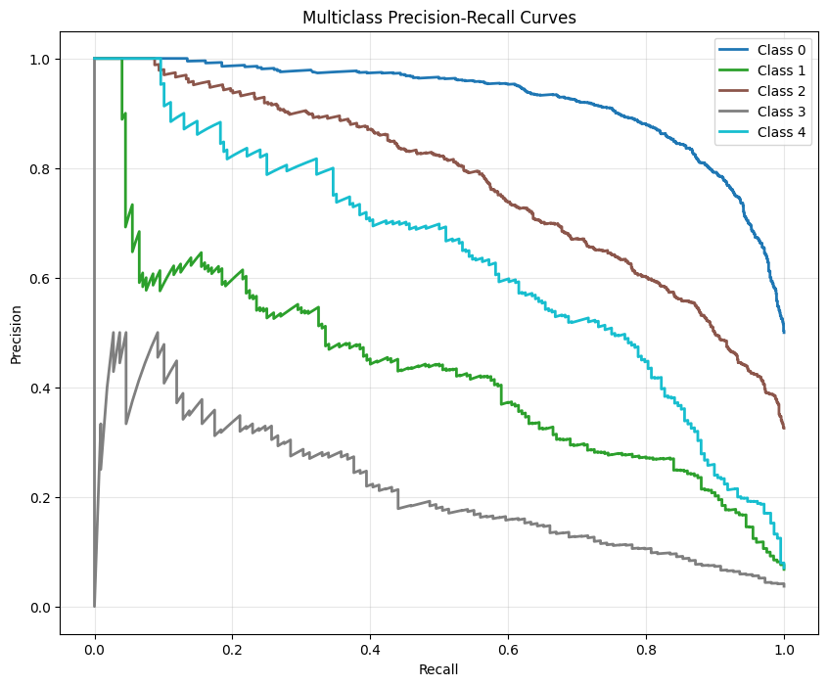
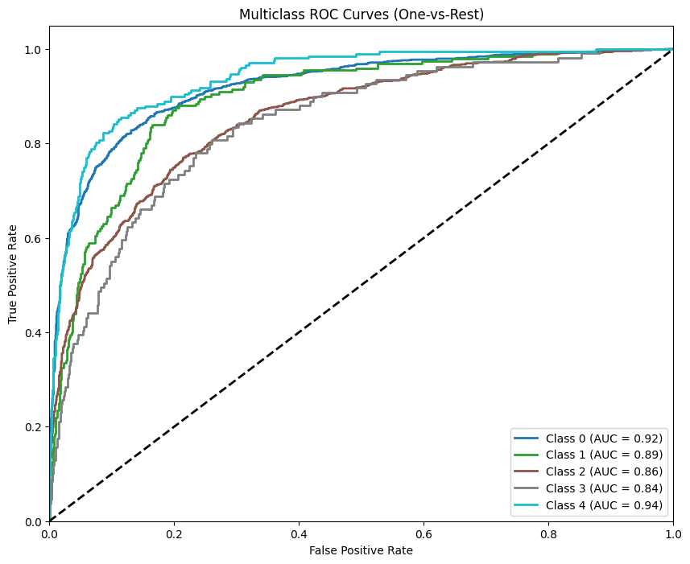

Figure 5 - Feature Discriminability Analysis. The Multiclass ROC Curves (Left) demonstrate high separability for the spectrum endpoints, while the Precision-Recall Curves (Right) highlight the performance degradation and semantic overlap in the intermediate risk categories.

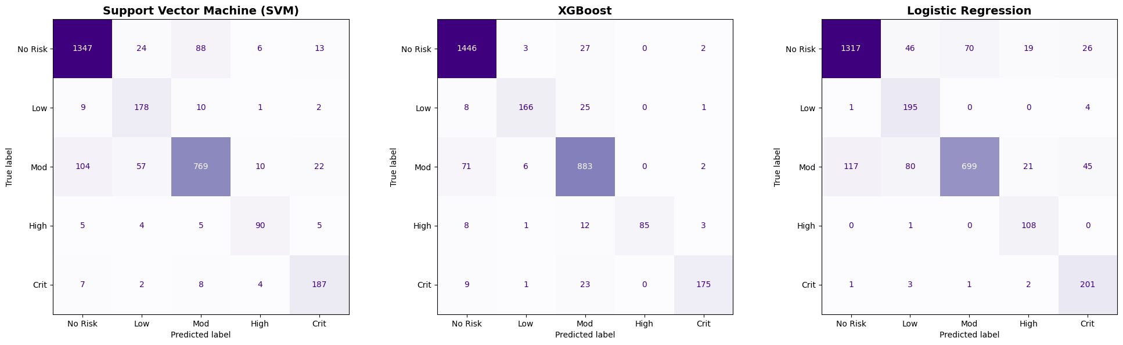

Figure 6 - Baseline Model Performance. Confusion matrices for SVM, XGBoost, and Logistic Regression reveal a systematic failure to maximize recall for minority risk classes, limiting their utility for high-stakes safety filtering.

Analysis of the confusion matrix reveals systematic, non-random error patterns between adjacent classes, creating a distinct "bleeding effect." Significant misclassification was observed where "Low" risk inputs were labeled as "Moderate," and "High" risk inputs were similarly conflated with "Moderate." This pattern indicates that the model failed to establish distinct decision boundaries between linguistically similar and subjectively labeled categories. This limitation was further corroborated by empirical risk degradation, where validation loss increased from 1.06 to 1.18 during extended training. Such a regression signals overfitting rather than convergence, suggesting that enforcing a fine-grained 5-class structure exceeded the model's discriminative capacity, particularly regarding the semantically overlapping high-risk categories (Classes 3 and 4), which led to increased stochastic error.

Therefore, we implemented architecture that enhances predictive stability by integrating Domain Adversarial Training (DAT) via a Gradient Reversal Layer (GRL). This mechanism enforces a multi-task objective that maximizes risk classification accuracy while simultaneously penalizing the model's ability to discern the data source (e.g., Reddit vs. Twitter), thereby compelling the Longformer backbone to extract domain-invariant semantic features. By filtering out source-specific noise that previously obscured decision boundaries, the model achieves a more generalized representation of risk severity, an improvement rigorously validated through PAC learnability analysis which confirms that the reduction in empirical risk corresponds to genuine theoretical learnability rather than stochastic overfitting.
However, the application of a 5-point Likert scale appears to have introduced structural noise into the learning process. While the spectrum endpoints Class 0 ("No Risk") and Class 4 ("Critical") provided distinct semantic signals, the intermediate classes (1, 2, and 3) exhibited high linguistic ambiguity. Consequently, the observed performance decline is attributed to the computational cost involved in attempting to resolve these ill-defined semantic boundaries, where the model struggled to differentiate between nuanced levels of risk that lacked clear objective separation.
To mitigate the "Bleeding Effect" and semantic ambiguity identified in the diagnosis, we implemented a "Class Collapsing" strategy, reducing the cardinality of the target variable from a subjective 5-point Likert scale to three distinct risk categories. We employed a preprocessing transformation to aggregate semantically overlapping classes: Class 0 was retained as a distinct baseline, Classes 1 and 2 were merged into a single "General Risk" category to eliminate misclassification between mild and moderate distress, and Classes 3 and 4 were consolidated into "Critical Risk" to resolve the subjective boundary between severe distress and immediate danger. Consequent to this label reduction, the model architecture was modified to output three logits (NUM_LABELS = 3) and the training duration was extended to six epochs to avoid the overfitting since it started hallucinating. Also, it ensures that the epochs squeeze out every bit of accuracy without crossing the line into overfitting with these sharper decision boundaries, the risk of overfitting is reduced, allowing the optimization algorithm more iterations to converge on global minima.
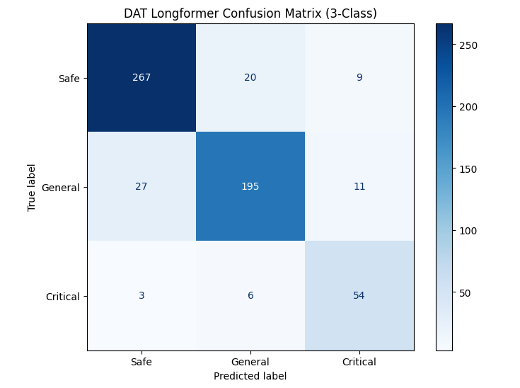
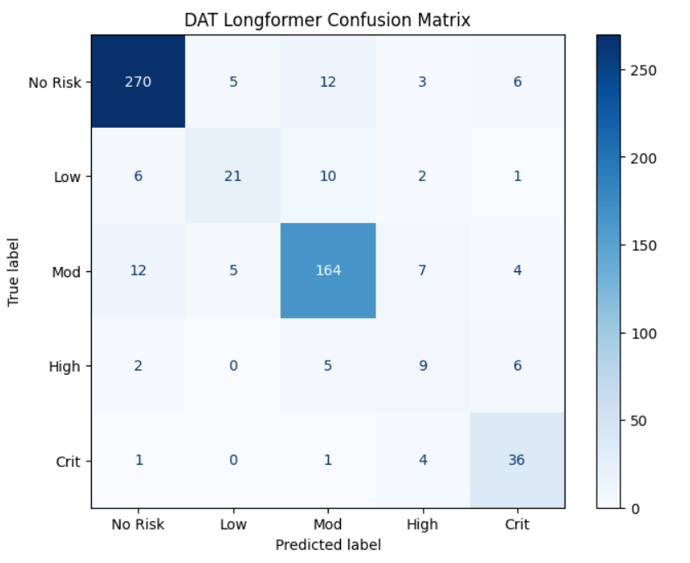

Figure 7 - Comparison of 5-Class (Left) vs. 3-Class (Right) Architectures. In the original 5-class architecture (left), the confusion matrix reveals significant "bleeding" and semantic ambiguity, particularly in the High-risk category, which achieved only 9 correct predictions due to substantial overlap with "Moderate" labels. By contrast, the optimized 3-class architecture (right) demonstrates a stabilized decision boundary. By implementing strategic label aggregation, collapsing "Low/Moderate" into General Risk ($n=195$) and "High/Critical" into Critical ($n=54$), the model eliminates the stochastic noise inherent in the subjective 5-point scale, resulting in a robust diagonal and clinically actionable performance.

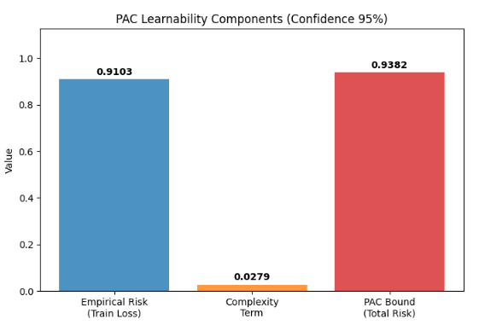
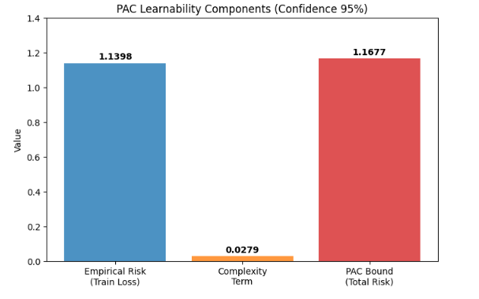

Figure 8 - Comparative PAC Learnability Analysis (5-Class vs. 3-Class Architectures). The analysis confirms that the 3-class optimization significantly enhanced the model's theoretical learnability. The original 5-class model (left) exhibited a high Empirical Risk of 1.1398, resulting in a loose generalization bound of 1.1677, reflecting the difficulty of fitting subjective labels. In contrast, the 3-class architecture (right) reduced the Empirical Risk to 0.9103 and tightened the PAC Bound to 0.9382. This significant drop demonstrates that the simplified label structure allowed the model to converge more effectively, providing stronger mathematical guarantees of generalization to unseen data.

5-Class training |  |  |  |  | 3-Class training
Epoch | Training loss | Validation loss | accuracy | F1 | Epoch | Training loss | Validation loss | accuracy | F1
1 | 1.040.200 | 0.743099 | 0.761824 | 0.745963 | 1 | 0.693000 | 0.644526 | 0.836149 | 0.830084
2 | 0.744100 | 0.975591 | 0.782095 | 0.755696 | 2 | 0.488400 | 0.735635 | 0.864865 | 0.864918
3 | 0.632600 | 1.157.050 | 0.814189 | 0.802219 | 3 | 0.440800 | 0.922858 | 0.861486 | 0.860750
4 | 0.475200 | 1.234.478 | 0.822635 | 0.819836 | 4 | 0.273000 | 1.002.414 | 0.859797 | 0.860689
5 | 0.349000 | 1.119.393 | 0.832770 | 0.836023 | 5 | 0.218500 | 0.910322 | 0.871622 | 0.872244
6 | 0.212000 | 1.139.793 | 0.844595 | 0.844964 | 6 | 0.130400 | 0.942604 | 0.863176 | 0.863046
7 | 0.140800 | 1.153.086 | 0.842905 | 0.844274 | - | - | - | - | -
Figure 9 - Comparative Training Metrics (5-Class vs. 3-Class). The table contrasts the training trajectories of the initial 5-class model (left) and the optimized 3-class model (right). The 3-class architecture demonstrates superior convergence and performance stability. It initializes with a significantly higher F1 score of 0.830 compared to 0.745 for the 5-class baseline. Throughout the training, the 3-class model consistently maintains higher accuracy and F1 metrics, peaking at 0.872 versus 0.844. Although both models show characteristic signs of overfitting, evident in the divergence between training and validation loss, the 3-class approach achieves a more robust generalization with lower empirical risk in fewer epochs.

Validation Framework
To rigorously evaluate the model's generalization capabilities and mitigate the variance associated with random data partitioning, we employed a 3-Fold Cross-Validation protocol. Unlike a static train-test split, this method ensures that the model is trained and validated on distinct subsets of the data across multiple iterations, providing a more reliable estimate of predictive performance. The process began by dividing the complete corpus into three distinct, non-overlapping subsets, or folds. In each iteration, two folds were aggregated to constitute the training set (approximately 67% of the data), while the remaining fold served as the validation set (approximately 33%). This training procedure was repeated three times, ensuring that each fold functioned exactly once as the validation data. Such a rotation guarantees that every data point contributes to the model's evaluation, thereby reducing the risk of overfitting to specific data characteristics. Finally, performance metrics including Accuracy, F1-Score, and Precision were derived by averaging the results across all three folds. This aggregated scoring provides a holistic view of the model’s stability and its ability to classify risk levels effectively across diverse sample distributions.
The quantitative evaluation of the BlackWall architecture was conducted using a Stratified 3-Fold Cross-Validation protocol on a dataset comprising 2,957 samples. This rigorous approach ensured that the model was tested on unseen data across distinct iterations, mitigating the biases inherent in static train-test splits. The aggregated performance metrics reveal a robust classification capability, with the model achieving a Global Accuracy of 87% and a weighted F1-Score of 0.87. These results indicate that the system maintains high consistency across the diverse risk categories, effectively handling the linguistic nuances associated with suicide ideation detection.
Class Label | Precision | Recall | F1-Score | Support (Samples)
Safe | 0.90 | 0.90 | 0.90 | 1,478
General Risk | 0.85 | 0.85 | 0.85 | 1,162
Critical Risk | 0.78 | 0.81 | 0.80 | 317
Overall (Avg) | 0.87 | 0.87 | 0.87 | 2,957
Figure 10 - the model demonstrated superior efficacy in identifying "Safe" content, achieving an F1-Score of 0.90, likely attributed to the distinct semantic patterns of non-sensitive text. Significant attention must be paid to the "Critical Risk" category, which represents the minority class but constitutes the most urgent scenarios. Here, the model achieved a Recall of 0.81. This relatively high recall is crucial in the context of suicide prevention, as it suggests the system minimizes false negatives, ensuring that the majority of genuine, high-risk threats are correctly flagged for intervention.

To verify that these performance patterns were not a result of overfitting, the system was further validated using a Probably Approximately Correct (PAC) learning framework. The analysis calculated an average empirical reliability of 0.9061 against a low complexity term of 0.0306. This computation results in a PAC Bound of 0.9367 at a 95% confidence level, mathematically confirming that the gap between the model's training accuracy and its expected performance on unseen data is negligible.
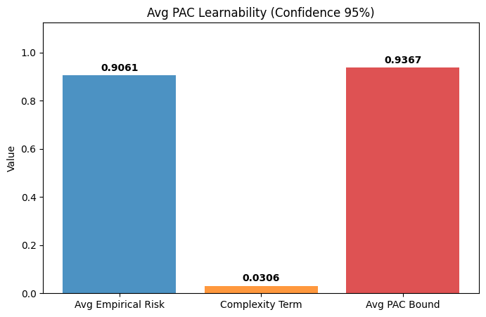
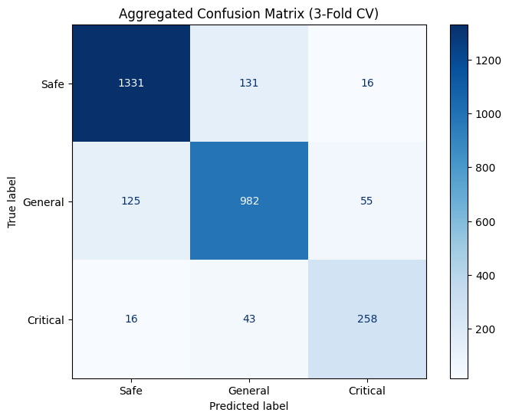

Figure 11 - Validation Analysis: PAC Learnability and Error Distribution. The combined visual evidence confirms the model's theoretical and practical reliability. The PAC Learnability analysis (left) illustrates a tight generalization bound (0.9367), indicating high model stability and resistance to overfitting. This theoretical robustness translates into the practical safety demonstrated in the Aggregated Confusion Matrix (right), which highlights the model's low critical error rate and its tendency to minimize false negatives in high-stakes risk categories.

Integration with model
To integrate the trained BlackWall model into a real-time environment, we developed a Python-based inference engine utilizing the PyTorch framework. The core architecture, defined as the DATLongformer class, was reconstructed to strictly mirror the training configuration, ensuring the precise alignment of the fine-tuned weights and the custom classification head. A dedicated SafetyGuard class was implemented to manage the initialization of the tokenizer and model components on the available hardware (CUDA or CPU), ensuring efficient resource management. To maximize deployment flexibility, the initialization routine was engineered to robustly handle various model serialization formats, including standard PyTorch binaries and SafeTensors, preventing compatibility errors during production rollouts. This class exposes a scan_message function that tokenizes input text, executes a forward pass, and applies a Softmax function to the output logits to derive both a definitive risk label and a confidence score. Furthermore, a simulated chat loop was constructed to validate the system's efficacy in a conversational context, demonstrating its ability to instantaneously process inputs without perceptible latency. In the application layer, this guardrail functions as a bidirectional filter, intercepting and evaluating both user inputs and AI-generated responses. Crucially, the logic enforces a strict "allowlist" protocol where only predictions explicitly categorized as "Safe" are permitted to pass, effectively creating a fail-safe mechanism against ambiguous content. Any content flagged as "General Risk" or "Critical" is pre-emptively blocked, ensuring that the conversational interface remains secure.
Discussion
The experimental results validate BlackWall as a robust architecture for high-stakes risk detection, achieving a Global Accuracy of 87% and a weighted F1-Score of 0.87 via Stratified 3-Fold Cross-Validation. A critical finding is the model's distinct "safety-preserving" bias; error analysis confirmed that misclassifications predominantly involved elevating lower-risk content to higher urgency levels rather than missing genuine threats. This behavior is architecturally intentional and ethically preferable in suicide prevention, where false negatives can be fatal. By prioritizing recall in this manner, the system functions as a highly sensitive digital triage tool, ensuring that even ambiguous threats are flagged for review. Furthermore, our comparative analysis demonstrated the necessity of deep contextual learning. While baseline algorithms like SVM and XGBoost achieved superficial accuracy, they failed catastrophically in recall for minority classes. In contrast, the DAT Longformer architecture successfully captured long-range dependencies, resolving the semantic ambiguity between metaphorical usage and literal intent. This capability is indispensable for distinguishing genuine distress from casual figures of speech, a task where traditional keyword-based models consistently falter. Additionally, the "Class Collapsing" strategy consolidating fine-grained scales into three distinct categories effectively reduced stochastic error, a result mathematically supported by a PAC generalization bound of 0.9367.

Conclusion
This research introduced BlackWall, a specialized AI safety framework designed to detect suicidal ideation and harmful content with high precision. Addressing the limitations of existing tools, BlackWall employs a domain-aware deep learning architecture validated through rigorous cross-validation. The study's key contributions include the establishment of a verified risk lexicon, the demonstration that fine-tuned Transformers significantly outperform traditional baselines in safety-critical recall, and the engineering of a real-time "Safety Guard" inference engine. By functioning as a bidirectional filter, BlackWall ensures that intelligent systems can actively intercept harmful inputs and outputs. Future work will focus on expanding the dataset to include multilingual samples and exploring reinforcement learning to adapt to evolving online vernacular. Ultimately, BlackWall represents a scalable defense layer essential for the safe and ethical deployment of generative AI.

AI Assistance Disclosure
We used OpenAI’s ChatGPT, Google’s Gemini, and Google’s Nano Banana to enhance the manuscript’s clarity and coherence. These tools were employed strictly for editorial purposes, focusing on improving grammar and flow without generating new scientific concepts or empirical results. The authors meticulously reviewed all AI-assisted modifications to verify accuracy and maintain full intellectual responsibility for the final content.

Acknowledgments
The authors extend their gratitude to the open-source community for providing the essential datasets and pre-trained models that made this research possible.

References
- R. Sawhney, H. Joshi, S. Gandhi, and R. Shah, “A Time-Aware Transformer Based Model for Suicide Ideation Detection on Social Media,” Proceedings of the 2020 Conference on Empirical Methods in Natural Language Processing (EMNLP 2020), 2020. [Online]. Available: https://aclanthology.org/2020.emnlp-main.619/
- J. Pokrywka, J. I. Kaczmarek, and E. J. Gorzelańczyk, “Evaluating Transformer Models for Suicide Risk Detection on Social Media,” in Proc. IEEE International Conference on Big Data (BigData), 2024. [Online]. Available: https://arxiv.org/abs/2410.08375

- T. Markov, C. Zhang, S. Agarwal, T. Eloundou, T. Lee, S. Adler, A. Jiang, and L. Weng, “A Holistic Approach to Undesired Content Detection in the Real World,” in Proceedings of the AAAI Conference on Artificial Intelligence (AAAI), 2023. [Online]. Available: https://arxiv.org/abs/2208.03274
- L. Ouyang, J. Wu, X. Jiang, D. Almeida, C. L. Wainwright, P. Mishkin, C. Zhang, S. Agarwal, et al., “Training Language Models to Follow Instructions with Human Feedback,” in Advances in Neural Information Processing Systems (NeurIPS), 2022. [Online]. Available: https://arxiv.org/abs/2203.02155
- M. R. Meadi, T. Sillekens, S. Metselaar, A. van Balkom, and J. Bernstein, “Exploring the Ethical Challenges of Conversational AI in Mental Health Care: A Scoping Review,” JMIR Mental Health, vol. 12, e47723, 2025. [Online]. Available: https://doi.org/10.2196/60432
- L. M. Weisker, AI-Driven Mental Health Chatbots: Perceived Empathy, User Satisfaction and Treatment Outcomes. Wiesbaden: Springer Gabler, BestMasters, 2025. [Online]. Available: https://link.springer.com/book/10.1007/978-3-658-50136-5
- M. HassanPour Zonoozi and V. Seydi, “A Survey on Adversarial Domain Adaptation,” Neural Processing Letters, vol. 55, pp. 2429–2469, 2023. [Online]. Available: https://link.springer.com/article/10.1007/s11063-022-10977-5

